Config server credential :

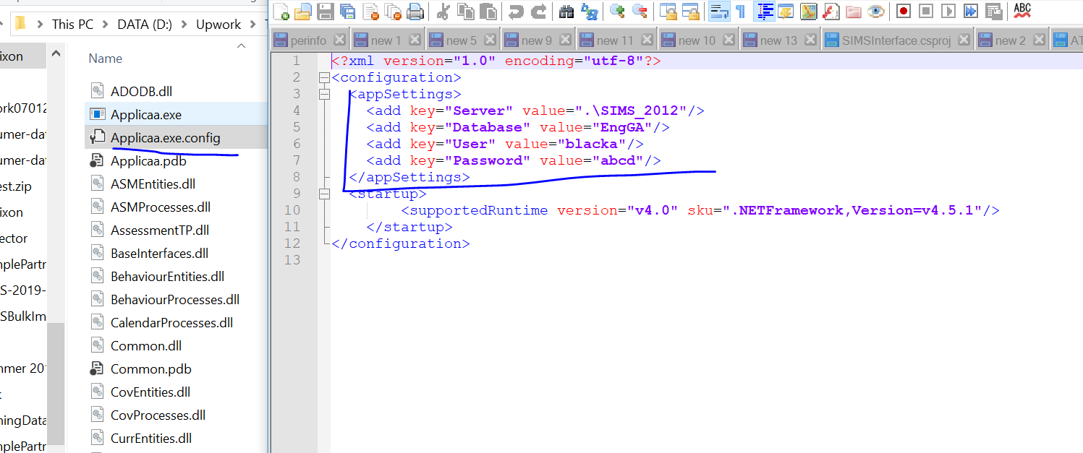

Run the MIS app:

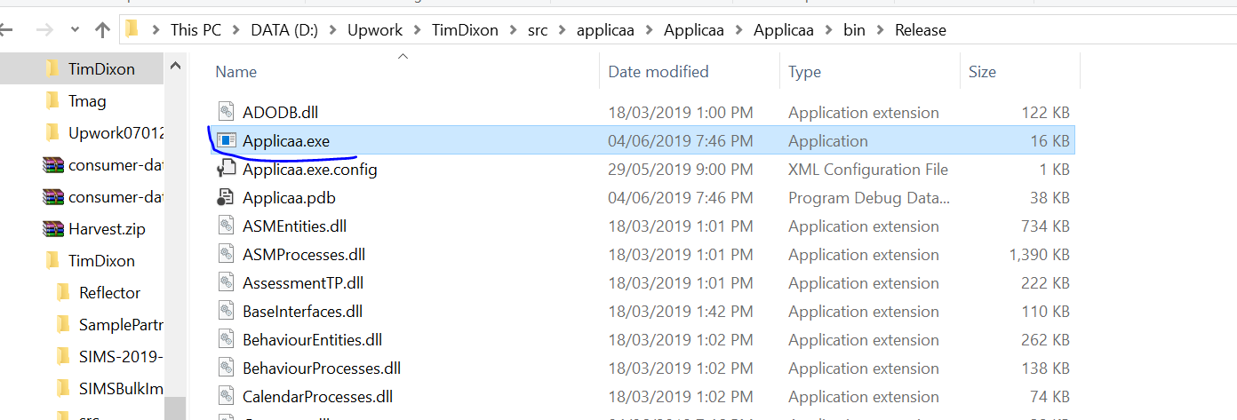

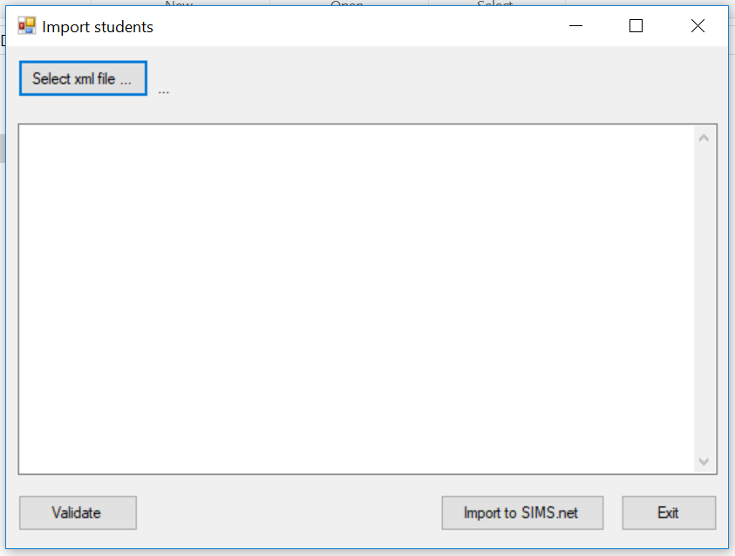

Select the xml file to import:

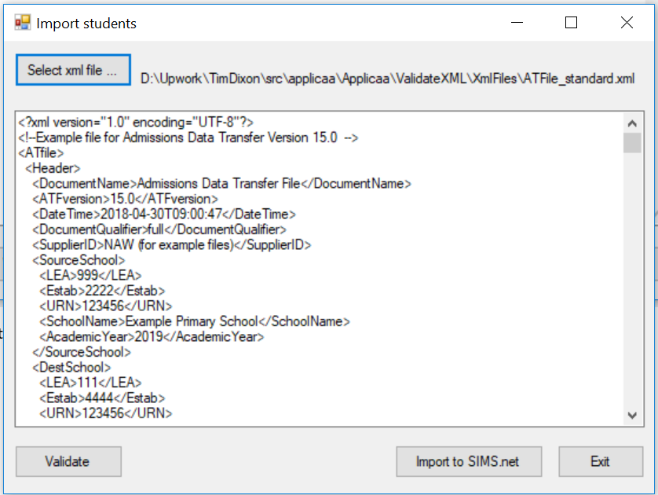

You can manually check the file is valid or not:

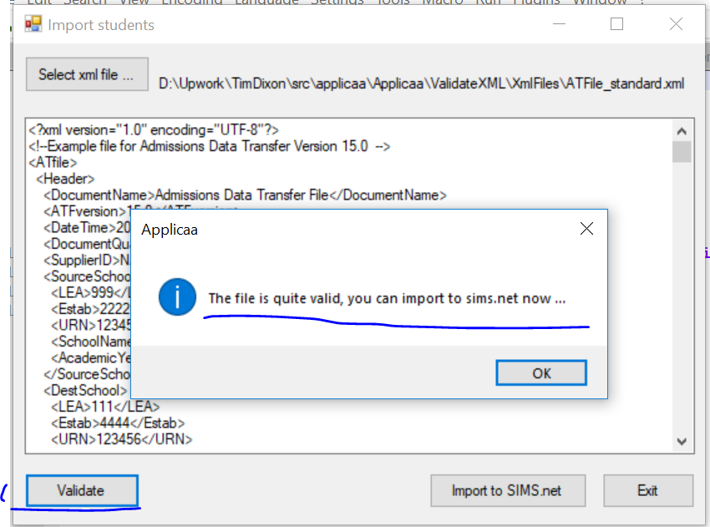

The file is ok, we are going to import students data now:

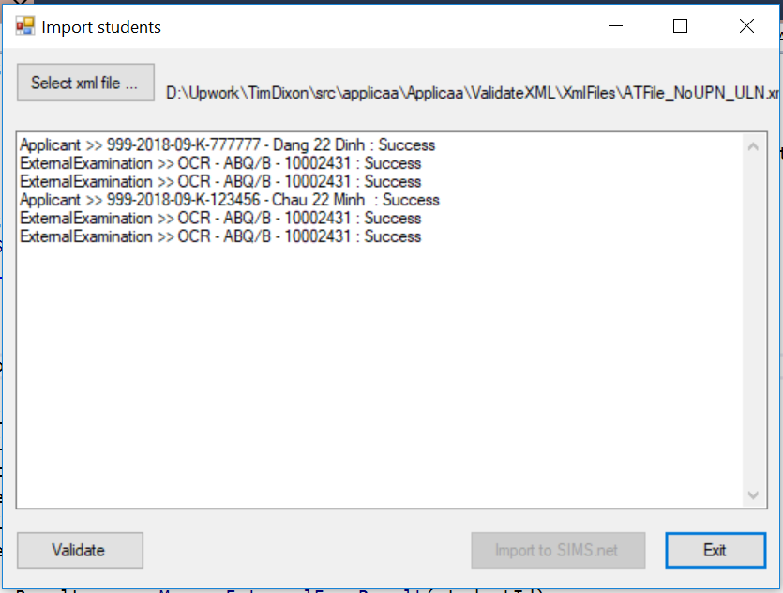

Import data success now, we go to SIMS.net to check the data :

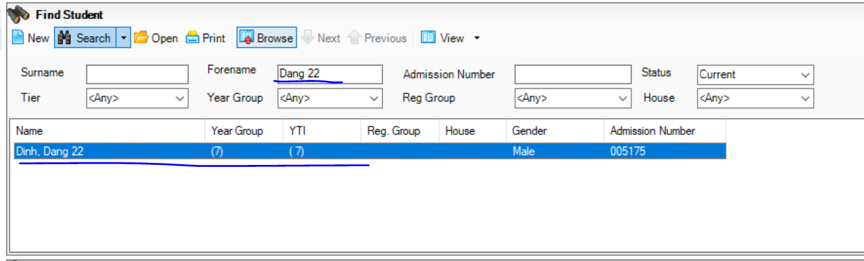

And check the external examination data :

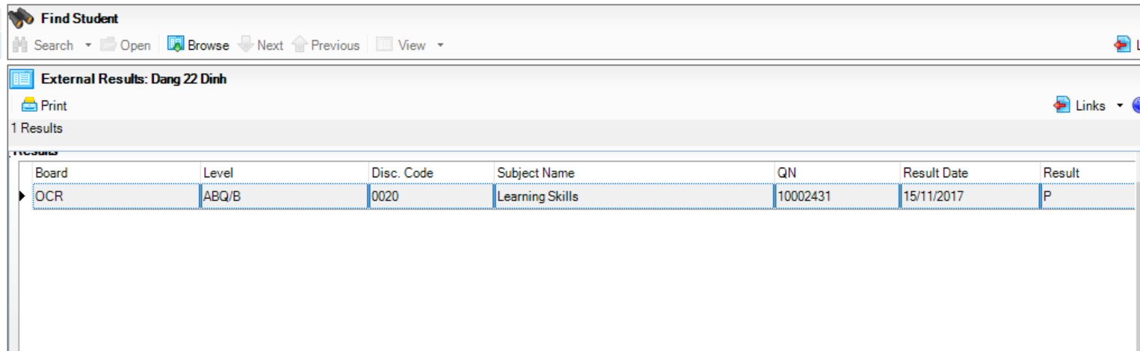

You can go to log folder to see the logging messages:

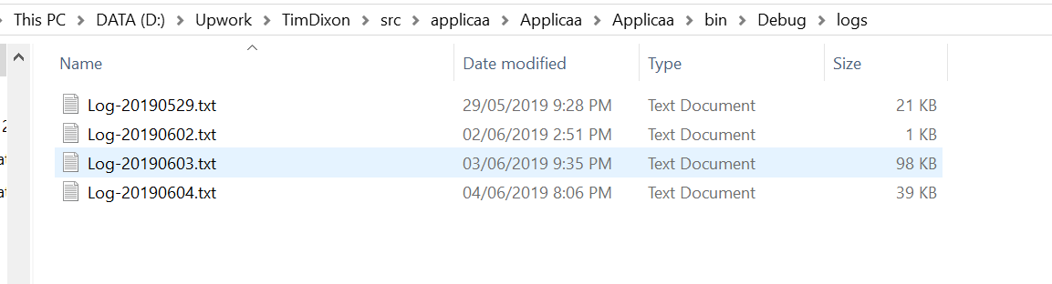

Thanks for attending !